WEEK - 2
TASK - 1
import java.util.*;

class Student {
int id;
String name;
double cgpa;

Student(int id, String name, double cgpa) {
this.id = id;
this.name = name;
this.cgpa = cgpa;
}
}

class Checker implements Comparator<Student> {
public int compare(Student s1, Student s2) {
// CGPA decreasing
if (s1.cgpa != s2.cgpa) {
return Double.compare(s2.cgpa, s1.cgpa);
}

// Name alphabetical order
if (!s1.name.equals(s2.name)) {
return s1.name.compareTo(s2.name);
}

// ID increasing
return Integer.compare(s1.id, s2.id);
}
}

public class Solution {
public static void main(String[] args) {
Scanner sc = new Scanner(System.in);

int n = sc.nextInt();
ArrayList<Student> students = new ArrayList<>();

for (int i = 0; i < n; i++) {
int id = sc.nextInt();
String name = sc.next();
double cgpa = sc.nextDouble();

students.add(new Student(id, name, cgpa));
}

Collections.sort(students, new Checker());

for (Student s : students) {
System.out.println(s.name);
}

sc.close();
}
}

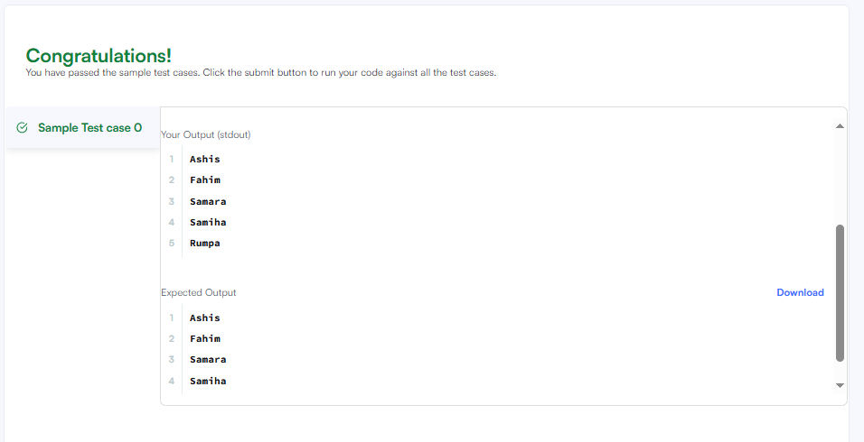
TASK 2
class Solution {
public int pivotIndex(int[] nums) {
int total = 0;
int leftSum = 0;

// Find total sum
for (int num : nums) {
total += num;
}

// Check each index
for (int i = 0; i < nums.length; i++) {
int rightSum = total - leftSum - nums[i];

if (leftSum == rightSum) {
return i;
}

leftSum += nums[i];
}

return -1;
}
}
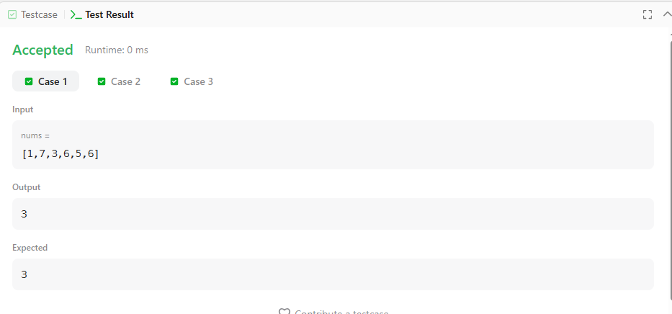

TASK - 3
class Solution {
public int[] shuffle(int[] nums, int n) {
int[] result = new int[2 * n];

for (int i = 0; i < n; i++) {
result[2 * i] = nums[i];
result[2 * i + 1] = nums[n + i];
}

return result;
}
}
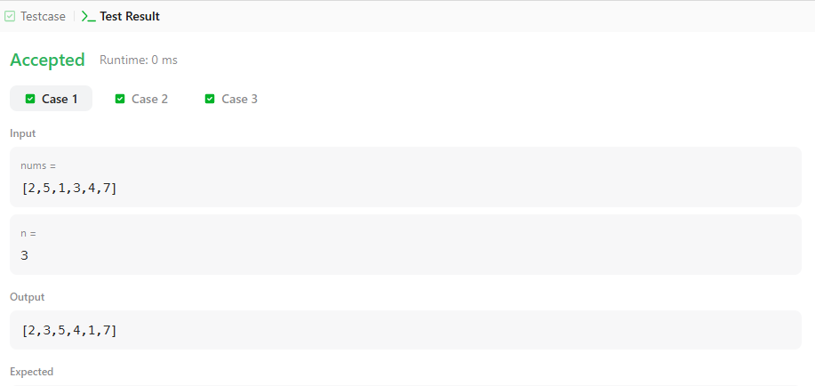

TASK - 4
class Solution {
public int removeElement(int[] nums, int val) {
int k = 0;

for (int i = 0; i < nums.length; i++) {
if (nums[i] != val) {
nums[k] = nums[i];
k++;
}
}

return k;
}
}
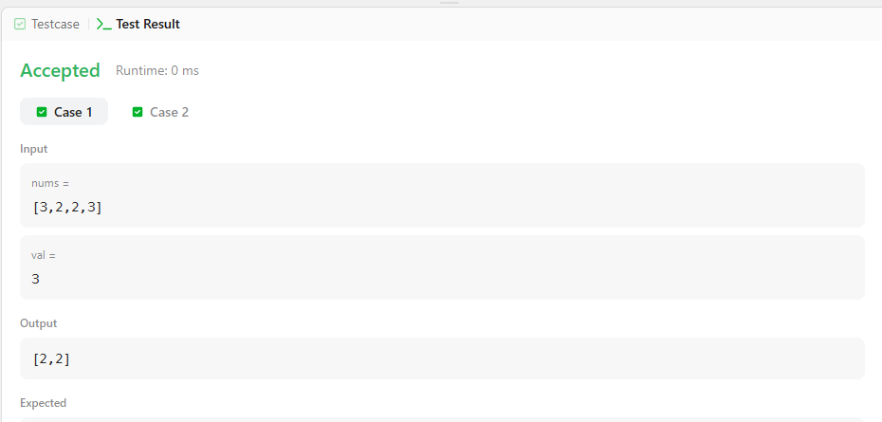

TASK - 5
class Solution {
public int removeDuplicates(int[] nums) {
int k = 1;

for (int i = 1; i < nums.length; i++) {
if (nums[i] != nums[i - 1]) {
nums[k] = nums[i];
k++;
}
}

return k;
}
}
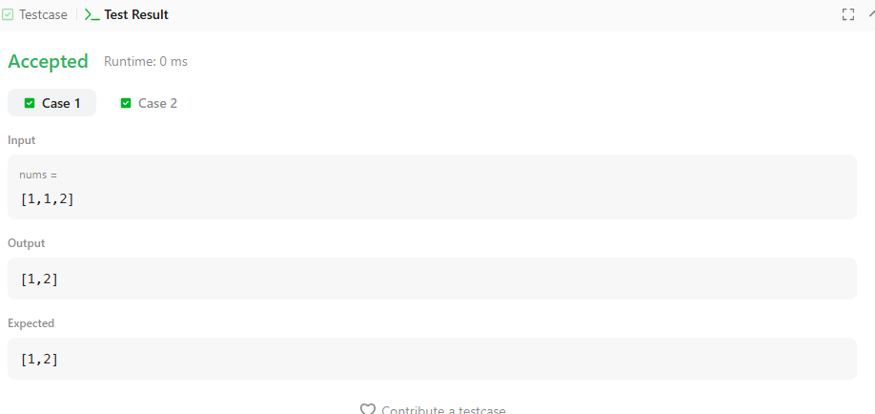
TASK - 6
class Solution {
public int maxSubArray(int[] nums) {
int currentSum = nums[0];
int maxSum = nums[0];

for (int i = 1; i < nums.length; i++) {
currentSum = Math.max(nums[i], currentSum + nums[i]);
maxSum = Math.max(maxSum, currentSum);
}

return maxSum;
}
}
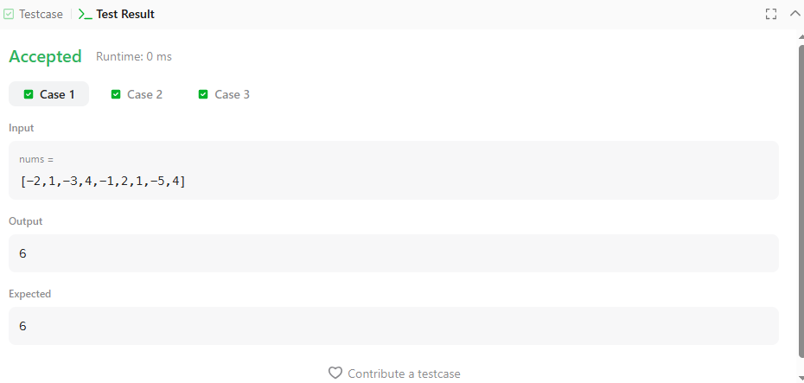

TASK - 7
class Solution {
public int largestAltitude(int[] gain) {
int altitude = 0;
int highest = 0;

for (int i = 0; i < gain.length; i++) {
altitude += gain[i];

if (altitude > highest) {
highest = altitude;
}
}

return highest;
}
}
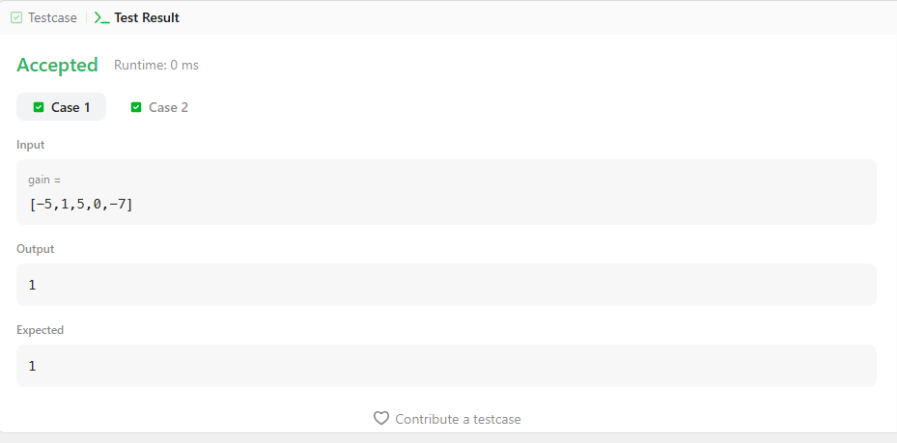

TASK - 8
class Solution {
public int maxSubArray(int[] nums) {
int currentSum = nums[0];
int maxSum = nums[0];

for (int i = 1; i < nums.length; i++) {
currentSum = Math.max(nums[i], currentSum + nums[i]);
maxSum = Math.max(maxSum, currentSum);
}

return maxSum;
}
}
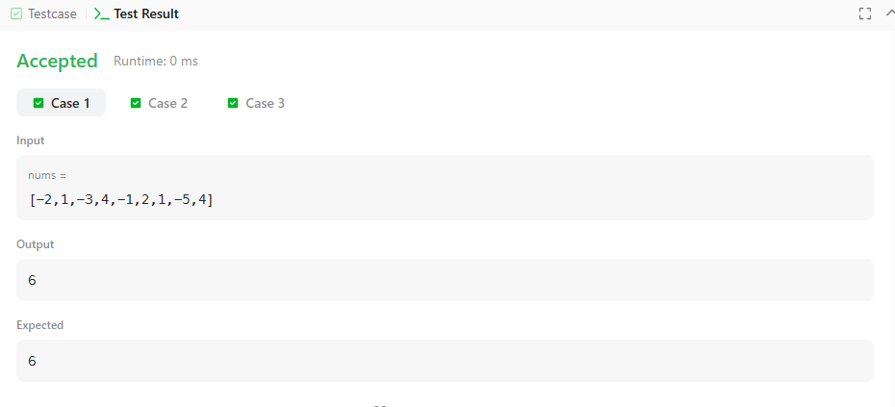

TASK - 9
import java.util.*;

class Solution {
public List<List<String>> groupAnagrams(String[] strs) {
HashMap<String, List<String>> map = new HashMap<>();

for (String s : strs) {
char[] chars = s.toCharArray();
Arrays.sort(chars);

String key = new String(chars);

if (!map.containsKey(key)) {
map.put(key, new ArrayList<>());
}

map.get(key).add(s);
}

return new ArrayList<>(map.values());
}
}
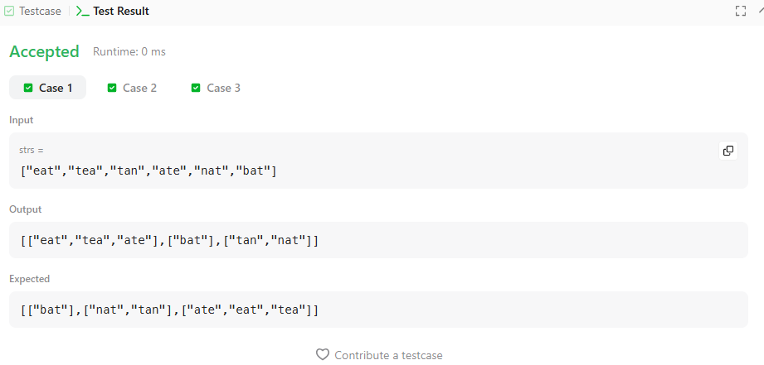

TASK - 10
import java.util.*;

class Solution {
public int[] topKFrequent(int[] nums, int k) {
HashMap<Integer, Integer> map = new HashMap<>();

// Count frequency
for (int num : nums) {
map.put(num, map.getOrDefault(num, 0) + 1);
}

// Buckets based on frequency
List<Integer>[] bucket = new List[nums.length + 1];

for (int num : map.keySet()) {
int freq = map.get(num);

if (bucket[freq] == null) {
bucket[freq] = new ArrayList<>();
}

bucket[freq].add(num);
}

// Get k most frequent elements
int[] result = new int[k];
int index = 0;

for (int i = bucket.length - 1; i >= 0 && index < k; i--) {
if (bucket[i] != null) {
for (int num : bucket[i]) {
result[index++] = num;

if (index == k) {
break;
}
}
}
}

return result;
}
}
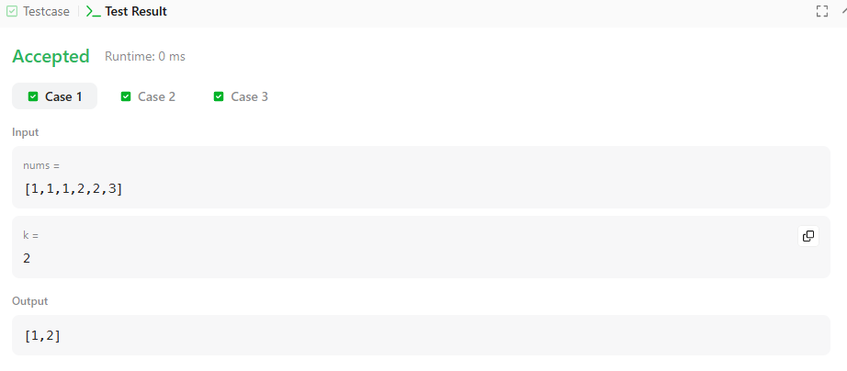

TASK - 11
import java.util.*;

public class Solution {
public static void main(String[] args) {
Scanner sc = new Scanner(System.in);

int n = sc.nextInt();
int m = sc.nextInt();

int[] arr = new int[n];

for (int i = 0; i < n; i++) {
arr[i] = sc.nextInt();
}

Deque<Integer> deque = new ArrayDeque<Integer>();
HashMap<Integer, Integer> map = new HashMap<Integer, Integer>();

int maxUnique = 0;

for (int i = 0; i < n; i++) {

deque.addLast(arr[i]);

if (map.containsKey(arr[i])) {
map.put(arr[i], map.get(arr[i]) + 1);
} else {
map.put(arr[i], 1);
}

if (deque.size() == m) {

if (map.size() > maxUnique) {
maxUnique = map.size();
}

int removed = deque.removeFirst();

if (map.get(removed) == 1) {
map.remove(removed);
} else {
map.put(removed, map.get(removed) - 1);
}
}
}

System.out.println(maxUnique);

sc.close();
}
}
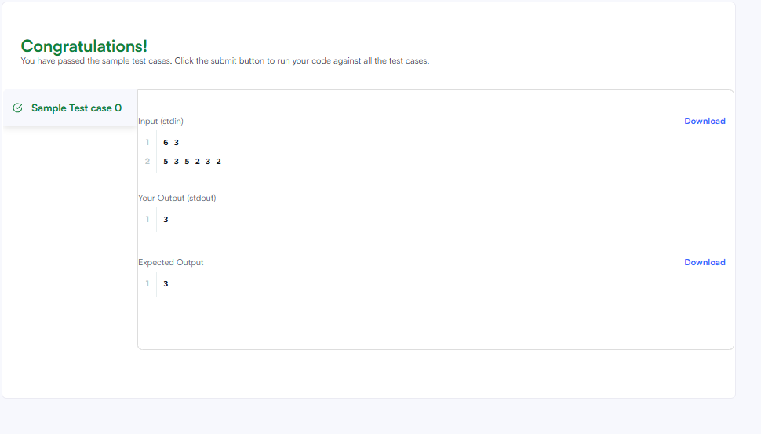
TASK - 12
import java.util.*;

public class Solution {
public static void main(String[] args) {
Scanner sc = new Scanner(System.in);

int n = sc.nextInt();

HashSet<String> set = new HashSet<String>();

for (int i = 0; i < n; i++) {
String first = sc.next();
String second = sc.next();

String pair = first + " " + second;

set.add(pair);

System.out.println(set.size());
}

sc.close();
}
}
